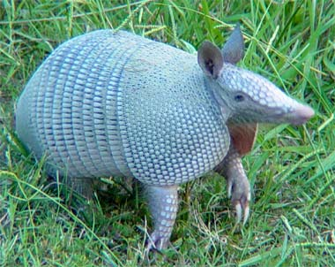

Armadillo’s Thanksgiving

We are so thankful for healthy, happy children, love and laughter, food, friends and family. The 4B Armadillos have decided to celebrate our blessings and also recognize our newly elected class President- Braelyn, vice president- Mykala and their team members. Our Camp Armadillo celebration will begin at 2:00pm on Tuesday, November, 23, 2010

Have a Blessed Thanksgiving

Our Healthy Lifestyles Menu
*Fruit Salad *Veggies and Dip
*Cheese and Crackers *Fruit Pies
*Juice *Water
Please indicate what you would like to contribute by writing your child’s name on the line next to an item.

Fruit Salad Items
Grapes _________________
Mandarin Oranges _________________
Bananas _________________
Blue Berries _________________
Strawberries _________________
Apples _________________
Cantaloupe _________________

Other Items
Cheese Cubes __________________
Crackers __________________
Veggie Tray __________________
Dip __________________
Juice packs __________________
Water (small bottles) __________________

Fruit Pies
Pumpkin Pie _____________________
Sweet Potato Pie _____________________
Apple Pie _____________________

Utensils
Plastic forks __________________
Plastic spoons __________________
Plates __________________
Napkins __________________

I would like to Volunteer*
Name ___________________________
Number ___________________________
* Please make sure you have completed volunteer paperwork with office

