FOURTH GRADE HOMEWORK

**Name:** _____________________________ #____ **Date**: ___05.20.11_______________________

**Homework Packets will go home on Fridays and they are due the following Friday.**

**No Excuses: Please do one page daily and do not procrastinate**

**PLEASE CHECK ASSIGNMENTS PAGE ON CLASS WEBSITE FOR HOMEWORK**

**WEBSITE: www.hsnature.org/4armadillos**

* **DAILY – Reading at home – Read for 20 mins. and fill out reading log.**

**Reading Logs will be checked on Mondays for the previous week. Logs not submitted on Mondays will receive a grade of zero**

* **MONDAY – Homework**
* **TUESDAY – Study Guide**

* **WEDNESDAY – Study Guide**
* **THURSDAY – Study Guide**
* **FRIDAY: Homework packets go home / Previous week’s Homework packets due**



**This week’s Homework Packet Includes:**

**Writing: Storyboard: Due 05/27/11 Final Digital Memory Book – Due May 31, 2011**

**Math: Practice sheets**

**Social Studies: Review your Study Guide**

**Science: Review your Study guide**

**Parent Signature: _____________________________________**

There are No Spelling Words this Week

Homework Instructions

Digital Memory Book

This is a fun project for you to reminisce about a special year in your life

1. Make an electronic memory book for your Fourth Grade Year at Harmony School of Nature and Athletics
2. You may use Power Point or Windows Movie maker
3. Memory Book should include pictures, sound and text
4. Use the storyboard template to make a plan for your memory book. – bring to class on 05/27/11
5. Final Project Due date - May 31.2011
6. Email your project to [pandega@harmonytx.org](mailto:pandega@harmonytx.org)
7. Save your project on a flash drive. ( do not make your file too large or it will be difficult to email)
8. You may upload your project to your student Weebly Website: optional

Ideas and suggestions for pages – You may choose from this list, in addition to your own creative ideas

* + Your picture and All About Me page – How you’ve changed
  + Classmates names and autographs
  + Pictures of classroom, school, outdoors, trips, projects
  + Poems, Artwork, music
  + Record a brief interview with teachers, parents, friends
  + Favorite moments, highlights, anecdotes

**The best Project will be selected to be presented at the Awards ceremony on June 2nd, 2011.**

Story Board

Name __________________________________ Title ____________________________

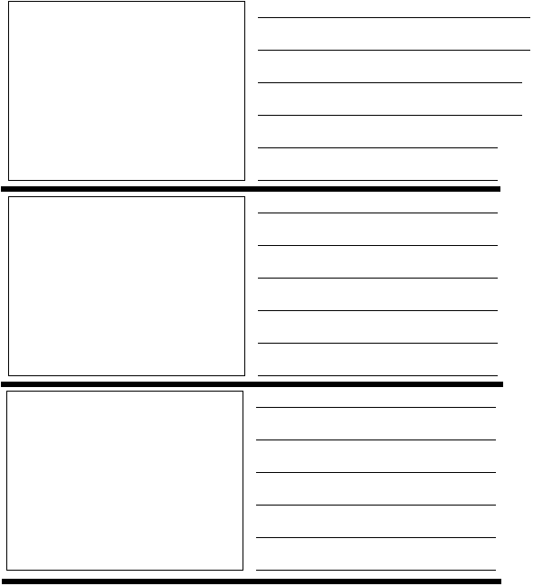

Story Board

Name __________________________________ Title ____________________________

