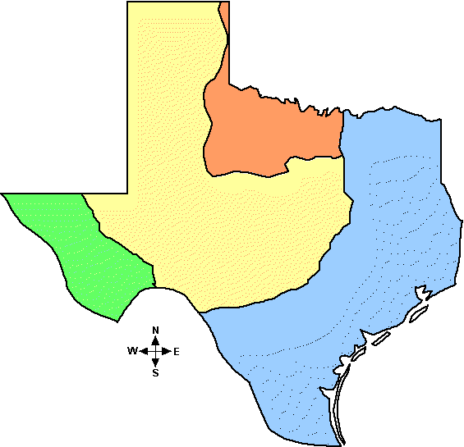
Social Studies Project

The Four Regions of Texas
In Social Studies we have been learning about the 4 main regions in Texas
Great Plains
Coastal Plains
Central plains
Mountains and Basins

Please help your child to glue recycled materials to fill in each region.
Be creative and make Texas come alive on paper.
Guidelines
Please do not use food products – Besides being a pest issue we are also aware of issues of hunger in our country and in our world.
Please include a drawing of the Texas flag - top right of the paper
Please include a caption about what makes Texas sparkle – center the caption below the map
A capitalized Title- center the title above the map
A Legend ( map key ) that shows which material represents which region - bottom left
Include a small picture or small drawing of a Texas symbol (e.g. state animal, flower) – top left
Add your special touch - bottom right
Suggestions for materials- nature products, fabric, newspaper, pencil shavings, sand – the possibilities are endless.
Feel free to embellish with sparkle and pizzazz to show that we are the shining star of the Southwest!

About the Four Natural Regions of Texas
By an eHow Contributor

Texas is a vast and diverse state comprised of many different natural elements and terrains. It is the second largest state in terms of land mass in the United States. Depending on which part of the state you travel to, you will encounter everything from mountains to plains.

The Facts
- Texas is divided into four major regions. These are: the Coastal/Gulf Plains, the Central Plains, the Great Plains, and the Mountains and Basins region. Each region has its own climate and natural resources. Each also has their own forms of industry, though farms and ranches are a prominent part of the commerce in each region of Texas.

Geography
- The Coastal/Gulf Plains region runs along the Eastern side of Texas, from the Sabine River to the Gulf of Mexico. This is the largest province taking up one third of the total land mass of the state. The terrain is flat and low in elevation. The Central Plains area is located in the Northern Central part of the state. The landscape in this region consists of limestone rock that creates short rolling hills covered with thick grass and hardwood trees. The Great Plains region is located mostly in what is considered the panhandle area of the state. This area is very flat with a high elevation that features canyons. It is a barren area with very few trees. The Mountains and Basins region is located all the way on the West side of the state; it borders the Pecos River as well as the Rio Grande. A segment of the terrain is mountainous with many plateaus and basins, while much of the rest of this part of the state is comprised of deserts.

Features
- The Coastal/Gulf Plains area features major cities like Houston and San Antonio. This region is rich with industry ranging from fishing to timber production. Oil and gas also play a key role in the economy of this area, as they do in all the regions of Texas. Fort Worth and Abilene are located in the Central Plains region. Because this part of the state contains fertile soil, produce accounts for a large portion of its industry. The Great Plains region includes such cities as Lubbock and Amarillo. Cattle ranching and cotton farming are major sources of commerce in this area. El Paso is a major city in the Mountains and Basins region, where ranching and oil are major factors in the economy.

Risk Factors
- Each region in Texas poses different risk factors in terms of possible climate and weather patterns. In the Coastal/Gulf Plains there is a very humid climate that includes a lot of rain. You should be aware of both tornados and hurricanes which are both naturally occurring weather elements in this region. The Central Plains receives a moderate amount of rainfall each year. Tornados are a risk factor in this area as well. The air is dry in the Great Plains, making dust storms common. The Mountains and Basin region is also extremely dry and typically receives less than eight inches of rain in the basin areas and less than twenty inches in the mountains, annually.

Benefits
- Each region contains different natural resources. From the cotton fields of the Mountain and Basin and Great Plains regions to the ports of the Coastal/Gulf Plains, each area is rich with essential resources. This range of resources is a huge benefit as it allows Texas to be one of the most self-sufficient states in the country.
Read more: About the Four Natural Regions of Texas | eHow.com http://www.ehow.com/about_4567476_four-natural-regions-texas.html#ixzz11HSWuhFc

