Willow and Ginkgo
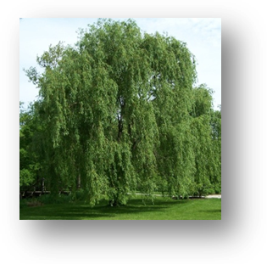
By Eve Merriam
The willow is like an etching,
Fine-lined against the sky.
The ginkgo is like a crude sketch,
Hardly worthy to be signed.
The willow’s music is like a soprano,
Delicate and thin.
The ginkgo’s tune is like a chorus
With everyone joining in.
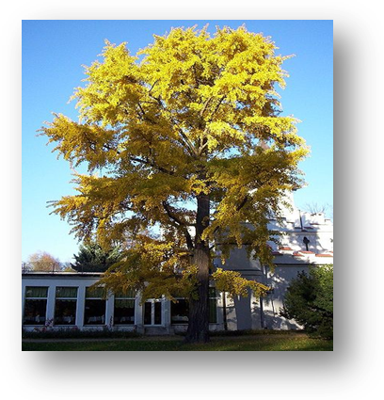
The willow is sleek as a velvet-nosed calf;
The ginkgo is leathery as an old bull.
The willow’s branches are like silken thread;
The ginkgo’s like stubby rough wool.

The willow is like a nymph with streaming hair;
Wherever it grows, there is green and gold and fair.
The willow dips to the water,
Protected and precious, like the king’s favorite daughter.
The ginkgo forces its way through gray concrete;
Like a city child, it grows up in the street.
Thrust against the metal sky,
Somehow it survives and even thrives.
My eyes feast upon the willow,
But my heart goes to the ginkgo.

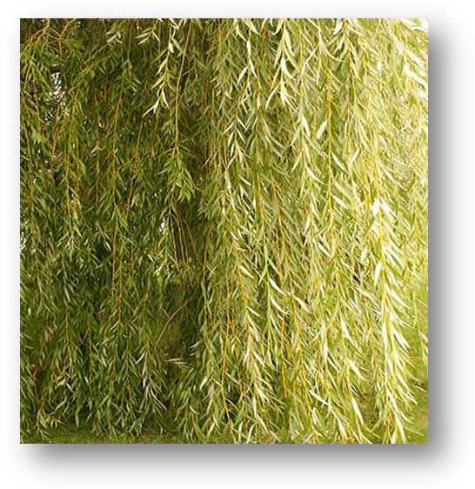
Willow 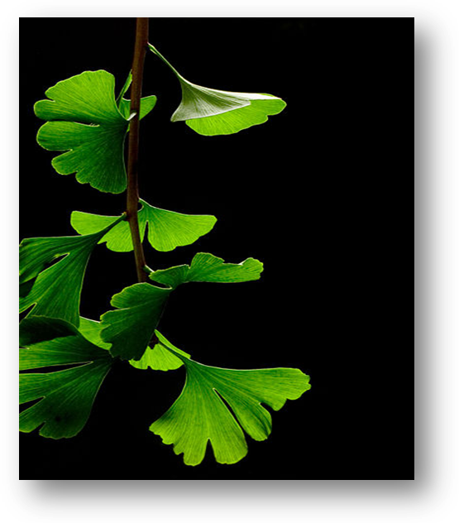Ginko

